**INTERFERENCE BY A WEDGE SHAPED FILM**

When a wedge shaped thin film of some transparent material is exposed to light, straight line

patterns of brilliant colours can be seen for This is due to interference of light reflected from

upper and lower surface of the film via the method of division of amplitude.

Let wedge shaped thin film of refractive index µ and angle of wedge ‘Θ’ be considered

within an air medium. It is assumed surfaces of the film have a high reflection coefficient.

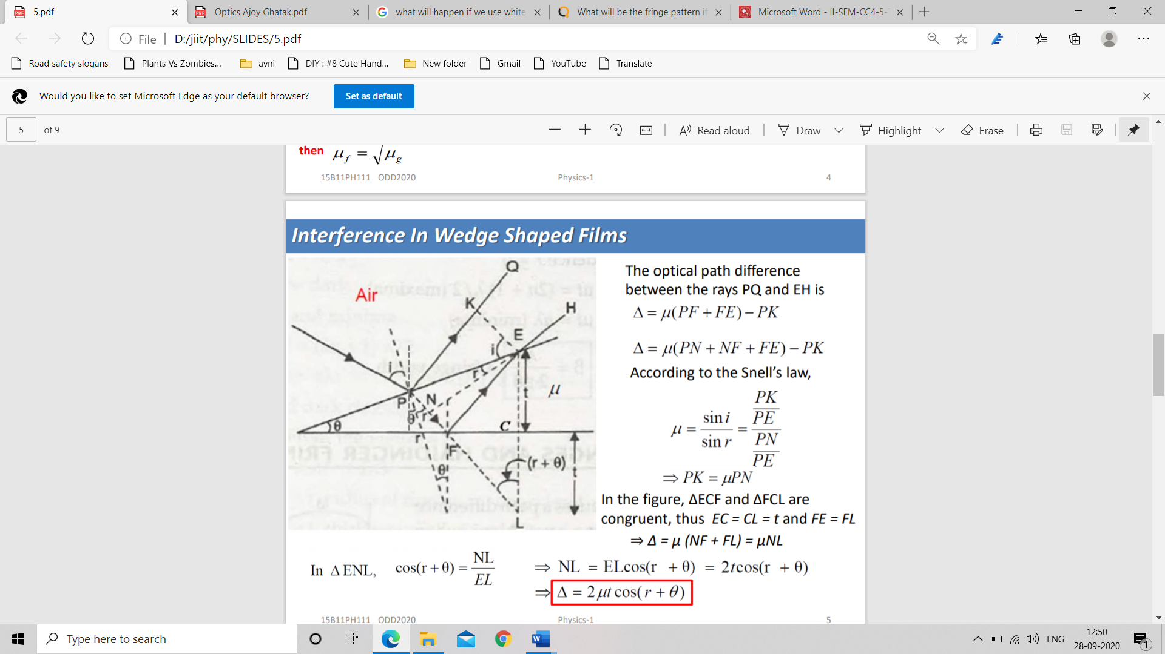The optical path difference between the rays PQ and EH is

Δ=µ(PF+FE)-PK

Δ=µ(PN+NF+FE)-PK

According to the Snell’s law,

µ=sini/sinr=(PK/PE)(PN/PE)

PK=µPN

In the figure, ΔECF and ΔFCL are congruent, thus EC = CL = t and FE = FL The optical path difference between the rays PQ and EH is According to the Snell’s law, ⇒ Δ = μ (NF + FL) = µNL

In ΔENL, cos(r+Θ) =NL/EL

NL=ELcos(r+Θ)=2t cos(r+Θ)

Δ=2µt cos(r+Θ)

In practical applications, where θ is very small, cos(r +θ ) ≈ cosr

➢ Constructive interference

2µt cos(r)=(2n+1)λ/2

➢ Destructive interference 2μt cosr = nλ where n = 0,1,2…..

For monochromatic light beam/sodium light beam incident on a wedge shaped film (λ and µ are constant), So change in path difference is only due to varying thickness of the film. But at a particular point, thickness is constant. So we get a bright or dark fringe at that point due to constant path difference.

Properties of fringes formed with **sodium light**:

➢Fringes of equal thickness

➢Fringe at the apex is dark.

➢Fringes are straight, parallel and equidistant.

➢Fringes are localized.

➢Fringes formed will be parallel to the edge OO’.

➢Bright and dark fringes of different orders will be

observed at different thickness of the film.

**For a white light source,**

The refractive index ‘µ’ and angle of wedge ‘α’ is constant. So, for a particular order, ‘t’ changes with wave length λ’. Hence for each wavelength of a polychromatic light a straight line pattern will be obtained for a given order. Hence corresponding to one order, a number of straight line fringes of different colours will be obtained.